SAN ANTONIO WATER SYSTEM PURCHASING DEPARTMENT

Issued By: Sandra Rios Date Issued: April 1, 2020
BID NO.: 20-3012

FORMAL INVITATION FOR BEST VALUE BID (BVB) FOR ANNUAL CONTRACT
FOR EMERGENCY RESPONSE AND HAZARDOUS/NON HAZARDOUS WASTE
TRANSPORTATION AND DISPOSAL SERVICES
ADDENDUM 3

Sealed bids, one (1) Original and seven (7) copies, addressed to the Purchasing Director, San Antonio Water System, 2800 US Hwy 281 North, Administration Bldg., 5th Floor, San Antonio, TX 78212 will be received until 3:00 p.m., April 13, 2020 and then publicly opened and read aloud for furnishing materials or services as described herein below,

The San Antonio Water System Purchasing Department is willing to assist any bidder(s) in the interpretation of bid provisions or explanation of how bid forms are to be completed. Assistance may be received by visiting the Purchasing Office in the SAWS Main Office, 2800 US Hwy 281 North, San Antonio, TX 78212, or by calling (210) 233-3819.

(Contractor’s Insurance Requirements Attached)

This invitation includes the following:

Invitation for Bids Specifications and General Requirements
Terms and Conditions of Invitation for Bids Price Schedule

The undersigned, by his/her signature, represents that he/she is authorized to bind the Bidder to fully comply with the Specifications and General Requirements for the amount(s) shown on the accompanying bid sheet(s). By signing below, Bidder has read the entire document and agreed to the terms therein.

Signer’s Name: ________________________________ Firm Name: ___________________________________
(Please Print or Type)

Address: ______________________________________
_____________________________________________

Signature of Person Authorized to Sign Bid City, State, Zip Code: ___________________________

Email Address: _______________________________ Telephone No.: ________________________________

Fax No.: _____________________________________
Please complete the following:
Prompt Payment Discount: ______% _______days. (If no discount is offered, Net 30 will apply.)

Please check the following blanks which apply to your company:
Ownership of firm (51% or more):
___Non-minority ____Hispanic ___African-American ____Other Minority (specify) ____________________
___Female Owned ___Handicapped Owned ___Small Business (less than $1 million annual receipts or 100 employees)
Indicate Status: ___Partnership ___Corporation ____Sole Proprietorship ____Other (specify) _______________
Tax Identification Number:____________________

To report suspected ethics violations impacting the San Antonio Water System, please call 1-800-687-1918.

***** This Addendum 3 is issued for Bid 20-3012 to do the following:
- Provide questions and responses
- Update language, pg 22
- Price schedule pg 47-57 is revised in its entirety and replaced with attachment titled - ATTACH D TAB4 Rev APR.
- Extend Due date

IT IS NECESSARY TO RETURN THIS ADDENDUM 3 AS PART OF YOUR BID SUBMISSION

******************************************************************************

1. Provide questions and responses:

1.TCEQ State Waste Fees will apply to most wastes identified. Can these be added as separate line items in your bid? That can potentially save you money as we’re not having to assume weight of containers and therefore can give you more accurate rates, plus fees at cost based on actual weights.

ANSWER: SAWS appreciates this comment, ADDENDEUM 3 includes an updated price sheet. Each line item on price schedule is to be all inclusive (to include fees).

2.Can you add a line for e-manifests fees? This is a per manifest fee, but since there’s no guarantee on amount of materials to be shipped per manifest (i.e. could be 1 drum per location), we have to assume worst case and add that total cost to each drum. Setting this out as a separate line item would allow us to save money in particular on drum loads when there are multiple line items and/or containers.

ANSWER: SAWS appreciates this question and comment. Therefore, a separate line item for e-manifest fees will be added to the price sheet. This only applies to hazardous waste identified on a manifest.

3.I didn’t see notation of requirement for a performance deposit. Please confirm that a deposit is not required for this bid request.

ANSWER: Performance deposit is not required for this contract.

4.Your requirement for a list of names for subcontractors, is that only for personnel working on SAWS sites or for the disposal facilities as well?

ANSWER: SAWS appreciates this comment and question. Per the RFP, please provide a list of all subcontractors that will be used throughout the contract (this includes treatment, storage, disposal and laboratory operations. SAWS will obtain a list of employees who will be on SAWS sites when contract is awarded.

5.It appears that SAWS has a no-landfill requirement. Please confirm or identify if there’s specific wastes that are allowed for landfill. I just want to confirm as this will affect overall pricing for disposal somewhat significantly. If that’s the case, would it be acceptable to provide and alternative cost to dispose of by landfill as an option for savings?

ANSWER: SAWS appreciates this question. Per the RFP, Waste types including, but not limited those enumerated in this Contract shall not be disposed in a landfill or by underground injection unless first authorized in writing by SAWS Resource Protection and Compliance If any waste shall be landfill, will need to receive authorization from SAWS.(pg22, #3)

6.Please confirm types of training requirement under Paragraph 31 C: Presumed to be DOT and RCRA (40 hour, 24 hour and 8 hour refresher). Please advise is any additional training required.

ANSWER: SAWS appreciates this question, Training is in accordance with 40 CFR 262.16(b)(9)(iii) for a Small Quantity Generator.

7.Please confirm under Paragraph 31 C if waste(s) is transferred to one of our locations prior to end disposal (i.e. manifested to us, we take title and ship as our waste to final disposal), is this required to be authorization each time or can a blanket authorization be obtained? Also, if materials are manifested directly to a third party location, but stops at our 10 day facility, is additional authorization required for such?

ANSWER: SAWS appreciates this question, See question 4

8.It was noted that analytical services may be requested from Contractor from time to time, but there is no lines included on the bid for passing along the cost of analytical testing when required to completed by contractor. Can this be added as a separate line item?

ANSWER: SAWS appreciates this question, ADDENDEUM 3 includes an updated price sheet.

9.I do not see a place on the bid for Emergency Response pricing, only a limitation to the number of personnel without prior approval. ER labor and standard service labor is not the same rate due to the understood requirements of ER, where it takes precedence over any other projects. Is this something that should be submitted on our standard ER pricing sheets or will this be added to the bid?

ANSWER: SAWS appreciates this question, ADDENDEUM 3 includes an updated price sheet.

10.There is no notation on the bid sheet that identified if the materials are currently shipped as hazardous, non-hazardous or universal waste currently. Most materials are identifiable by category, but there are a few that are questionable. Is there potential to denote that on the bid or do we need to submit those line items separately for clarification? The question relates to the EPA Status of the materials. In most cases we can assume, but there’s a few depending on concentrations and clarification that could go either way. It would be helpful to have either an EPA Code included or at a minimum if materials are Haz, Non-Haz or Universal. See notes in blue on the attached file. I have assumed the codes on some, but for instance, Lithium batteries can be haz, deactivated or non-haz. Haz can ship as universal. Some companies call D001, some call D003. If D003, it limits some of athe facilities that can take the materials in.

ANSWER: SAWS appreciates this question; ADDENDEUM 3 includes an updated price sheet.

11.Page 51, Lines 45 & 46 are lab packs.
  - This doesn’t indicate solids or liquids. Separation of liquids and solids could improve pricing.
  - For lab packs, hazardous materials are not identified. If we understood what this typically includes, we could provide a better rate, as opposed to worst case rate.
  - Bid Sheet doesn’t include rates for Lab Pack Chemist and helper. Can this be provided as a separate line item since they don’t fall under the same pricing as general labor?

ANSWER: SAWS appreciates this question. A) Line item will has been added to the attached price sheet to indicate solids vs liquids lab packs B) A separate rate will not be included for a Lab Pack Chemist and helper.

12.Corrosive Liquids and/or corrosive liquids with metals are not identified as acid/base or type of acid/base. By doing so, it would help us price more competitively and not assume worst case.

ANSWER: SAWS appreciates this question; ADDENDEUM 3 includes an updated price sheet to distinguish between acid and base.

13.Bid Lines 61-65: What Organic acids are talking about and what concentrations are typical?

ANSWER: SAWS appreciates this question. After reviewing the chemicals listing of the laboratory, this line item will be removed from the price sheet. Updated price schedule attached.

14.Please provide additional information on COM Drain/Sump Enzyme Treat.

ANSWER: SAWS appreciates this comment. The COM Drain/Sump Enzyme Treatment is for the cleanout of the Car Wash Sump Cleaning. This line item will be updated on the attached price sheet with the corrected terminology

2. Update language-pg 22:

Original language,pg22:
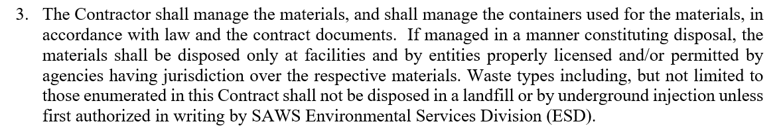

New language in bold,pg 22:
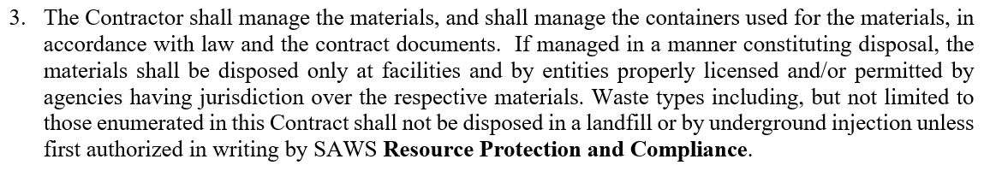

3. Price schedule pg47-57 is revised in its entirety and replaced with “ATTACH D TAB4 RevAPR” attachment.

4. New date due:

IT IS NECESSARY TO RETURN THIS ADDENDUM 3 AS PART OF YOUR BID SUBMISSION

All other terms and conditions of the original bid remain unchanged.

Attachments: PRICE SCHED TAB4 , “ATTACH D TAB4 RevAPR”

